

Digital dashboards
User Manual

Developer: CEMIC
Authors: Fernando Poletta, Juan Gili, Maximiliano Giordano
Version 2.0

Intended Users, Administration, and Adaptation to Other Contexts

This application is intended to support public health surveillance and response activities and may be used by healthcare professionals, public health officers, and other personnel responsible for reporting, reviewing, managing, or analysing epidemiological information. Depending on the implementation context, municipal or regional health secretariats, public health authorities, or local National Statistical Office (NSO) teams may also carry out the application's administration, configuration, and maintenance.
The examples, screenshots, and simulated datasets included in this document are based on the administrative and data structure used by the National Institute for Statistics and Censuses (INDEC) in Argentina and are provided as a reference implementation. However, the application can be adapted for use in other countries and institutional settings, regardless of whether they have an established national epidemiological surveillance system. Detailed guidance on adaptation, configuration, and implementation in other national contexts is provided throughout this Technical Documentation and in the additional technical, support, and version-control materials available in the project GitHub repository.
The National Statistical Office (NSO), or an equivalent national technical authority, may support users by providing guidance on how to interpret the outputs of this tool. This may include advice on data quality, geographic standardisation, and the appropriate use of spatial indicators within national public health and statistical frameworks.

Digital dashboard
User manual
Unified CUSUM and geospatial analysis workflow

Documentation revision | June 2026
Language | English
Status | Aligned with the supplied current application source

Purpose. This document describes the current workflow and implementation represented by the supplied project files. It replaces older instructions that referred to previous navigation, storage, or output structures.
Contents

1. What the dashboard does 4
2. Input files and file management 5
3. Shared filters and CUSUM settings 6
4. Configure the Display page 7
5. Run and review the dashboard 8
6. How the two analyses use time and geography 9
7. Interpretation and exports 10
8. Troubleshooting 10
9. Glossary 11

1. What the dashboard does

The Digital Dashboard combines the CUSUM-RAP and Geospatial-RAP workflows into a single interface. A single upload and one set of shared filters feed the early-warning plots, the prevalence maps, the LISA maps, the tables, the prepared datasets and the downloads.
Navigation page | Purpose
Home | Overview and recommended workflow.
Dashboard | Upload, filters, CUSUM parameters, Run Analysis, outputs, tables and prepared data.
Display | Choose visible plots and maps, layout, table location, font size, decimals and optional reactive updates.
Help | Workflow summary and documentation links.

Two different location behaviours. The Locations selector limits the CUSUM units. The current Geospatial workflow, by contrast, still maps all units available at the selected geographic level and time window.

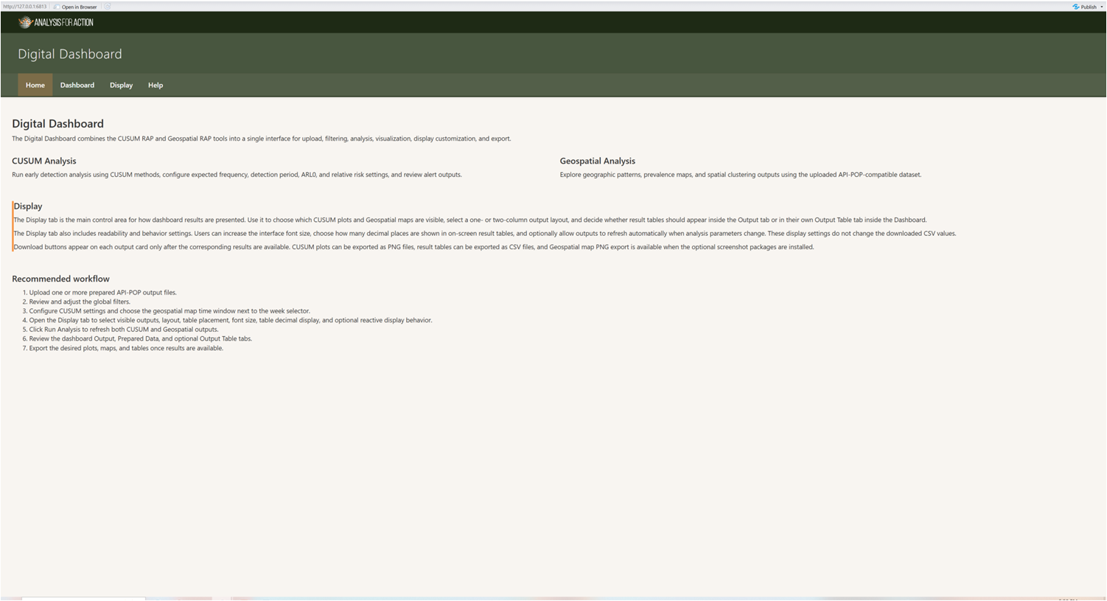

2. Input files and file management
Use prepared, API-POP-compatible delimited files. The file picker lists several extensions, but the supplied importer reads CSV-formatted text and detects comma or semicolon separators. CSV is therefore the reliably supported format for this build.
Column | Requirement | Meaning
country | Yes for current validation | The country value. The current source fixes active_country to Argentina.
year | Yes | The epidemiological year, 2000 to 2100.
week | Yes | The epidemiological week, 1 to 53.
level1 to level4 | At least one | The geographic hierarchy columns used by the configured level.
n_cases | Yes | The observed cases; the aliases are cases, case_count, count and n.
population | Required for maps | The population denominator; the aliases are n_population, pop and denominator.

Each uploaded file is stored in the current session with its row count, column count, epidemiological range, modification time and size. New files are active by default.
- Manage files: activate or deactivate files without re-uploading them.
- Remove inactive files: delete unchecked files from the current session.
- Clear all files: remove all uploaded data and analysis results from the session.
- Changing the active files invalidates the existing CUSUM and geospatial results, so the analysis must be run again.
No database write. The current Dashboard analyses the uploaded session data. It does not append the upload to a persistent epidemiological database.

3. Shared filters and CUSUM settings
Control | Effect
Geographic Level | Sets the administrative level used by both analytical engines.
Detection Period | The number of recent weeks used by CUSUM. The interface range is 8 to 260, with a default of 52.
Locations | Selected by default for all available units. Changes affect CUSUM only, in the current implementation.
Year | Year used for geospatial maps and the available week slider.
Map Time Window | Single week or inclusive week range. Range mode enforces at least two weeks when possible.
Expected Frequency | Automatic unit-level baseline or manual fixed expected weekly cases.
Target ARL0 | Used to display a recommended h.
Relative Risk | Used to calculate k.
h Threshold | The CUSUM alarm threshold.
Run Analysis | Refreshes both CUSUM and Geospatial outputs using the current active data and selections.
The calculated k and the recommended h appear under the CUSUM settings when enough information is available.
Run required after structural changes. Changes to the active data, the Geographic Level or the Locations require Run Analysis. Display settings can be changed before or after a run.

4. Configure the Display page
Display settings may be configured before the first analysis or changed afterwards. They control presentation, not the underlying data.
Setting | Options and behaviour
Visible outputs | CUSUM overview, CUSUM series, CUSUM process, Prevalence map, LISA map.
Output layout | One or two columns.
Results table location | Inside Output, or in a separate Output Table tab within Dashboard.
Display font size | Small, Medium, Large, or Extra large.
Decimal places | 0 to 6 decimals in on-screen tables; CSV precision is unchanged.
Reactive display | After a successful run, CUSUM parameter changes and map year, week, or time-mode changes can automatically refresh results.

Reactive display. Reactive display does not automatically apply active-file, geographic-level, or location changes. Those changes still require Run Analysis.
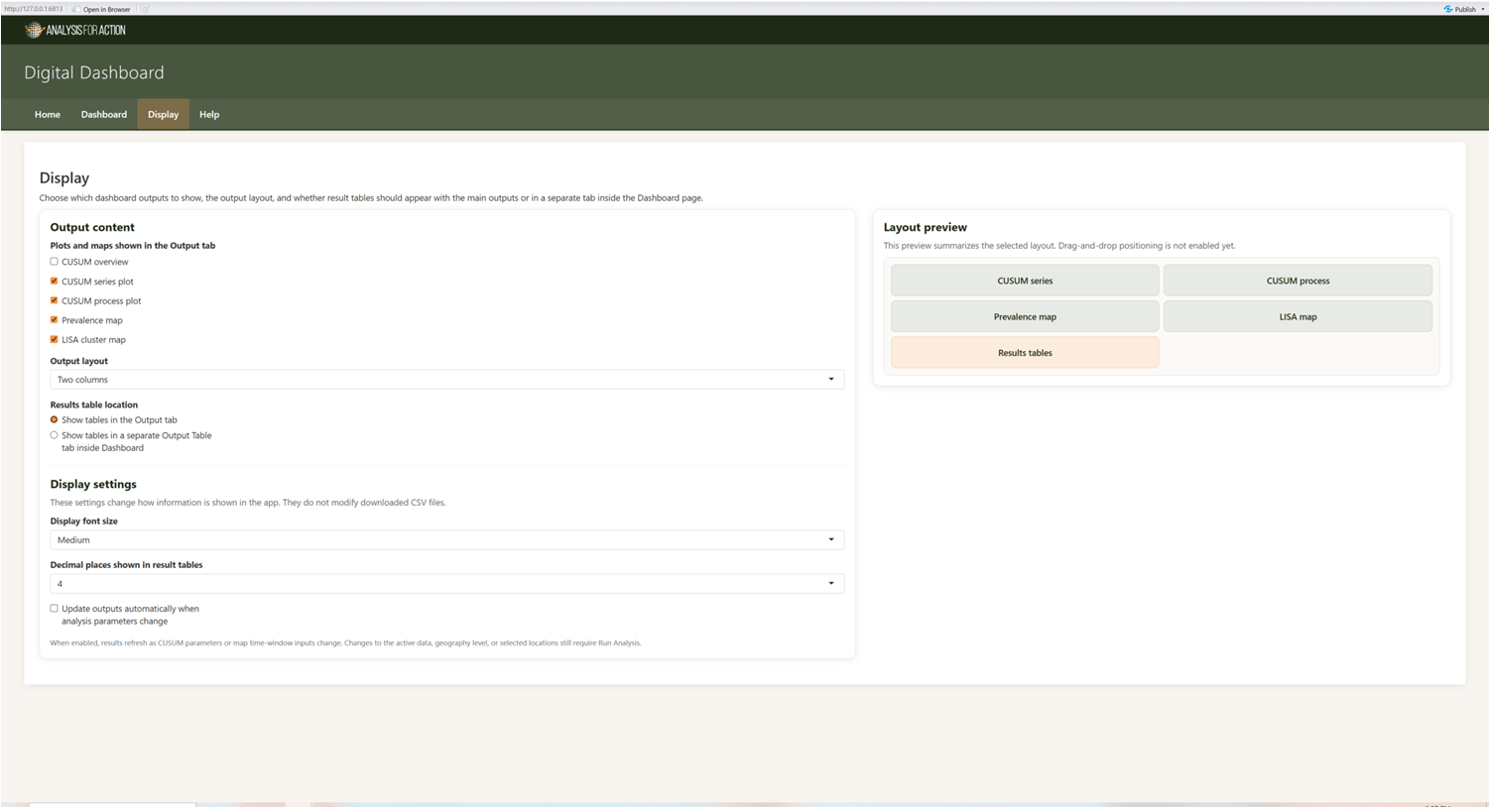

5. Run and review the dashboard
- Upload and activate the required CSV files.
- Set the Geographic Level, Locations, Detection Period, Year and Map Time Window.
- Configure the CUSUM parameters.
- Optionally, configure the Display page.
- Select Run Analysis.
- Review the Output, the Prepared data, and the optional Output Table tab.
CUSUM outputs
- CUSUM overview: an alarm heatmap across the selected CUSUM units.
- CUSUM series plot: the observed and expected values for the selected detailed unit.
- CUSUM process plot: the cumulative statistic and the threshold.
- CUSUM weekly results and unit-level reference tables.
Geospatial outputs
- Prevalence map for all matched units at the selected level.
- LISA cluster map, using the same spatial units and time window.
- Global Moran summary where the data support it.
- Geospatial results table.
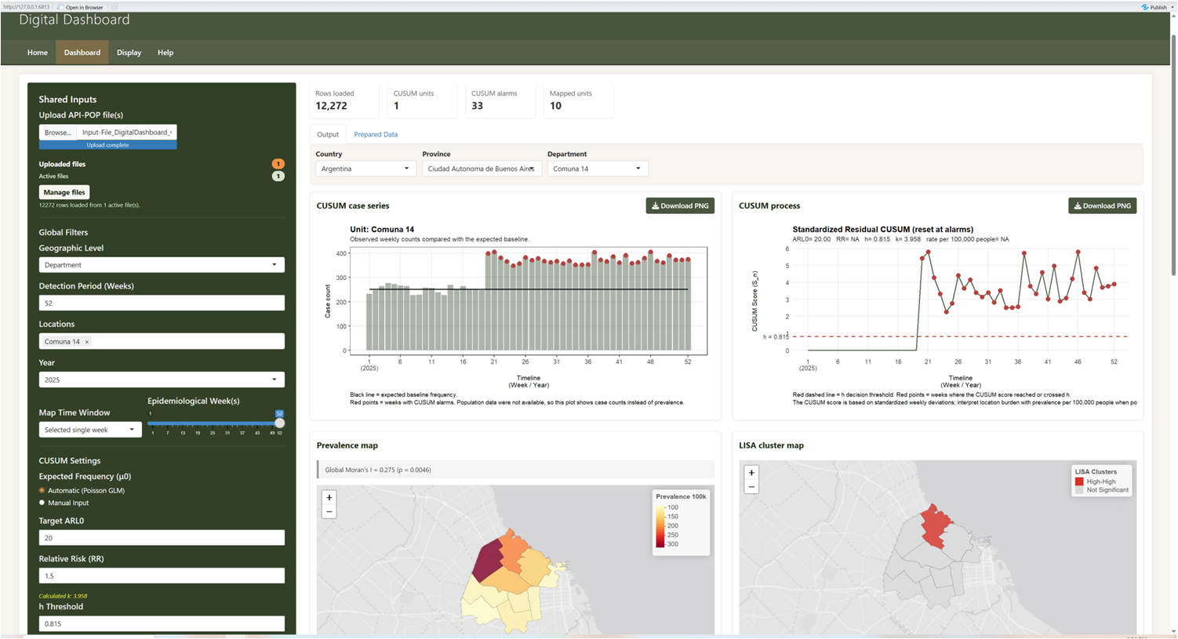

6. How the two analyses use time and geography

Dimension | CUSUM | Geospatial
Locations | Restricted to the selected Locations. | The current implementation ignores the Locations subset and uses all units at the geographic level.
Detection period | Controls the recent CUSUM window. | Not used.
Year | CUSUM preparation uses the available weekly history, rather than the map Year selector. | Filters the map data to the selected year.
Week selection | Not controlled by Map Time Window. | Uses the selected single week or inclusive range.
Population | Optional for count CUSUM. | Required for prevalence.
Geographic level | Builds CUSUM units at the selected level. | Loads and joins the configured layer for the selected level.
Avoid misinterpretation. Do not assume that a selected Locations subset also clips the maps. The current maps remain a complete level-wide comparison. The Locations selector restricts the CUSUM analysis alone, whereas the maps continue to display every unit at the selected geographic level.

7. Interpretation and exports
- CUSUM alarms are early warnings that require epidemiological review.
- Prevalence maps are descriptive, and depend on the quality of the numerator and the denominator.
- Global Moran describes the overall spatial autocorrelation, whereas LISA describes the local clusters and outliers.
- Display choices do not change the analytical values.
Export | Typical content
CUSUM PNG | The selected heatmap, series or process plot.
Geospatial map PNG | The current map, when screenshot support is installed.
CUSUM CSV | The weekly results or the unit reference values.
Geospatial CSV | The joined spatial-analysis results.
Prepared CUSUM CSV | The dataset used by CUSUM.
Active standardised CSV | The combined active data, after column normalisation and code padding.

8. Troubleshooting
Problem | What to check
Uploaded XLSX or TSV does not load | Convert it to comma- or semicolon-delimited CSV, as the current reader is CSV-based.
CUSUM completes, but maps fail | The population, the GeoPackage, the map IDs, the selected level, or the year or week coverage may be missing.
Maps show all areas despite selected Locations | This is the expected current behaviour; the Locations subset restricts CUSUM only..
Range snaps to two weeks. | Range mode enforces at least a two-week span when more than one week exists.
Outputs look stale | Run Analysis after any change to the active data, the level or the location.
Map download missing | The optional screenshot packages may not be installed.
Documentation link fails on Linux. | Use the exact case-sensitive filenames included in the updated docs package.

Escalation package. When reporting a problem, provide the active filenames, the filter values, the CUSUM parameters, the Display settings, the exact error text and whether CUSUM, Geospatial or both failed.
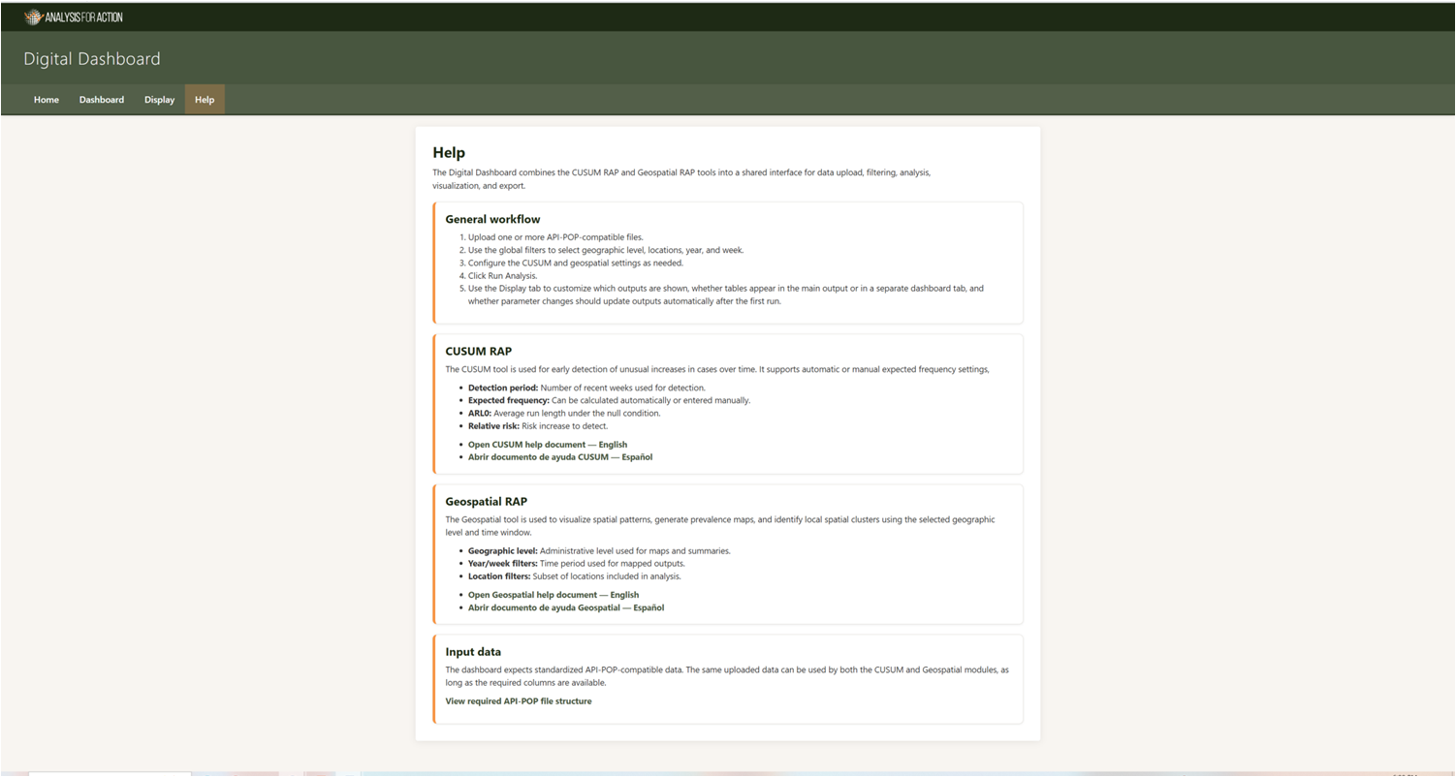

9. Glossary
Term | Meaning
Active file | An uploaded file currently included in the combined session data.
Standardized data | The uploaded columns after alias normalisation, numeric conversion, trimming and code padding.
Reactive display | An automatic rerun after eligible parameter changes, once an initial result exists.
Output Table | An optional Dashboard tab, used when the table placement is set to separate.
Prepared CUSUM data | The aggregated and completed weekly dataset used by the CUSUM engine
Map Time Window | The year-specific week or week range used only by the geospatial analysis.

